APPENDIX 3 – SAFEGUARDING INCIDENT FORM (DPS ONLY)
This form should be completed by the Designated Person for Safeguarding

Name of church / organisation
Contact details of church / organisation
Name of Designated Person for Safeguarding (DPS)
Contact details of Designated Person for Safeguarding
Name of concerned person or to whom disclosure was given
Contact details of concerned person or whom disclosure was given

INDIVIDUAL OF CONCERN - CONTACT DETAILS

Name
Date of birth
Address
Phone number / Email address

THE INCIDENT

What happened? (Nature of concern / disclosure made - use the person’s own words if known

When did it happen? (date, time)

Where did it happen? (specific location)

Who was allegedly involved and in what way? (includes witnesses)

ANY ACTION THAT HAS BEEN TAKEN

Yes |  | No
Have the carers or parents / guardians been informed? (Please tick)
If so, when and by whom?
Yes |  | No
Have the statutory authorities been informed?
If so, please complete the table:

Example:
Authority | Police
Name | Bobby
Position | Child abuse officer
Email contact | bobby@police.com
Phone contact | 077999
Contacted by | Minister
Date & time of contact | 1.30pm  1/4/15

Yes |  | No
Has the Local Association been informed?
(Please do so if the statutory authorities are involved)
If so, when and by whom?
Any other action taken:

FUTURE ACTION TO BE TAKEN

What action needs to be taken?

Who is responsible for this?

SIGNATURES

Signature of Designated Safeguarding Person |  | Signature of minister, or Church Safeguarding Team member
Date & time |  | Date & time

BODY MAP

Name of Individual of Concern_______________________________________________________

Name of person completing this form_______________________________________________

These diagrams are designed for the recording of any observable bodily injuries that may appear on the person. Where bruises, burns, cuts, or other injuries occur, shade and label them clearly on the diagram. Remember it’s not your job to investigate or to decide if an injury or mark is non-accidental. Listen, observe and pass it on.
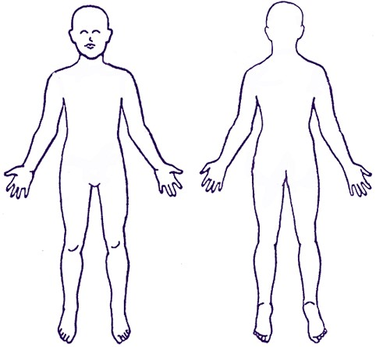
Front Back

Signature _________________________________________________

Date and time ____________________________________________

